**Supplier Engagement Workshop May 2016**

**Venue: Mewah Oils Sdn Bhd**

**Date: 11 May 2016**

* Mewah’s Sustainable Palm Oil Policy has resulted in a greater engagement with our suppliers.
* On 11 May 2016, we hosted the first Supplier Engagement Workshop at Mewah Oils Sdn Bhd, Port Klang. We managed to gather 17 palm oil millers and more than 20 participants to the Workshop.
* The supplier engagement program has provided us the opportunity to socialize our Sustainable Palm Oil Policy with our direct suppliers, providing them with a platform to discuss the implications and requirement of adopting similar policies.
* It has also provided us with a means to create awareness of the market demands for the need to delink our palm oil supply chain from deforestation, oil palm development of peatland and human rights abuses.

**List of Participants:**

|  |  |
| --- | --- |
| **No.** | **Company Name** |
|
| 1 | Kilang Minyak Kelapa Sawit Semantan Sdn Bhd |
| 2 | Lekir Palm Oil Mill |
| 3 | Sungai Kerang Palm Oil Mill |
| 4 | Felcra Jayaputra Palm Oil Mill |
| 5 | Tian Siang (Perak), |
| 6 | Tian Siang (Air Kuning) |
| 7 | Tian Siang (Pahang) |
| 8 | Bell-KSL Ladang Sua Manggis |
| 9 | Ulu Kanchong Palm Oil Mill (Gan Teng Siew Realty) |
| 10 | Tee Teh Palm Oil Mill |
| 11 | Sri Senggora Palm Oil Mill |
| 12 | ST Palm Oil Mill |
| 13 | Boustead Teluk Sengat (Trong) |
| 14 | Boustead Lepan Kabu Palm Oil Mill |
| 15 | Syarikat Cahaya Muda |
| 16 | Anson Oil Mill |
| 17 | Felda Global Venture (representative for Felda Serting Hilir Palm Oil Mill) |

**Group Photo**

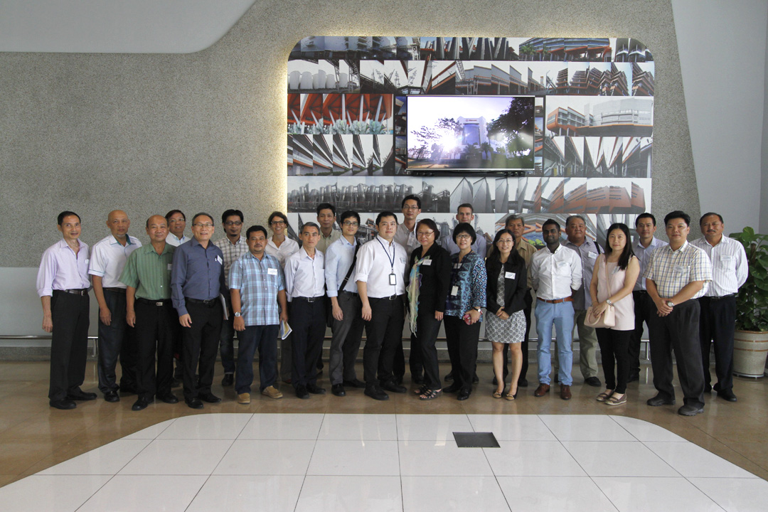

**Factory Visitation**

