CREATE VENDOR

USER MANUAL

User Manual No. | : | ACCT 09 – 1.0
User Manual Name | : | CREATE VENDOR
To-Be Reference No. | : | -
Author | : | LEE HWANG CHIN
Date | : | 23/05/2009

Document Version Control:
Version | Date | Issued / Change By | Remarks
1.0 | 23/05/2009 | Lee Hwang Chin | New

TABLE OF CONTENT

USER MANUAL 5
Objectives 5
1.0 Getting Started 6
1.1 Log in to Navision MOI Foods Malaysia Sdn. Bhd. 6
1.2 Select Finance (Mewaholeo) → Payables → Vendors 7
2.0 Preparation before create new vendor 8
2.1 Select Vendor’s List 8
2.2 Search Vendor’s Name 9
2.2.1 Place cursor on column ‘Name’ 9
2.2.2 Press button to set filter 9
2.2.3 Key in the Vendor’s Name and press OK. 9
3.0 Existing Vendor 10
3.1 Check Currency 10
3.1.1 Foreign Trade 10
3.2 Check Summary 11
3.2.1 Press button ‘Vendor’ > ‘Order Addresses’ to key in another order address for this vendor. 12
4.0New Vendor 12
4.1 Tab General 14
4.1.1 Key in general information e.g. Name, Name 2, Address, Address 2, Post Code/City, State/Country Code, Phone No and etc. 14
4.1.2 Set ‘Responsibility Center’ to ‘PG’ 14
4.1.3 Set ‘Blocked’ to ALL as this vendor will not be used for WP users 14
4.2 Tab Communication 15
4.2.1 Key in communication’s information. 15
4.3 Tab Invoicing 16
4.3.1 Key in posting group information. 16
4.4 Tab Payments 17
4.4.1 Key in payment information 17
4.5 Tab Receiving 18
4.5.1 For Account Department, ‘Location Code’ should set as ‘PG-TS’ 18
4.5.2 For CPD Department, ‘Location Code’ should set as ‘PG-PM’ 18
4.6 Tab Foreign Trade 19
4.6.1 Select Currency Code. 19
4.7 Tab Commercial Portal 20
4.8 Tab Registration 21
4.8.1 Key in Registration information. 21
5.0 Copy Vendor to MOI 22
6.0 How to Check Vendor Is Copied 23
6.1 Log in to Navision – MEWAHOLEO Industries Sdn. Bhd. 23
6.1.1 File > Database > Open 23
6.1.2 File > Company > Open 23
6.2 Select Finance (Mewaholeo) → Payables → Vendors 24
6.3 New Vendor Is Copied 25

USER MANUAL

Objectives
User allow to create their new vendor for finance or packing material purpose.

Getting Started

1.1 Log in to Navision MOI Foods Malaysia Sdn. Bhd.
1.1.1 File > Database > Open
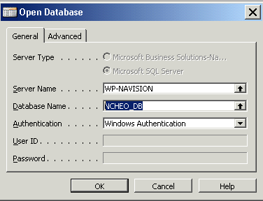

1.1.2 File > Company > Open
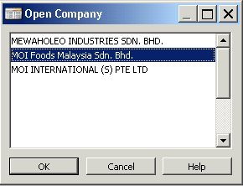

1.2 Select Finance (Mewaholeo) → Payables → Vendors

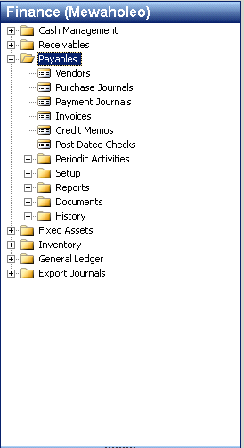

Preparation before create new vendor
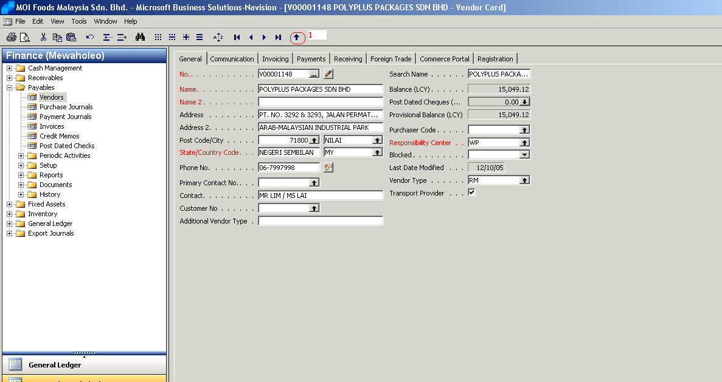

2.1 Select Vendor’s List
2.1.1 Press button to view data in list.

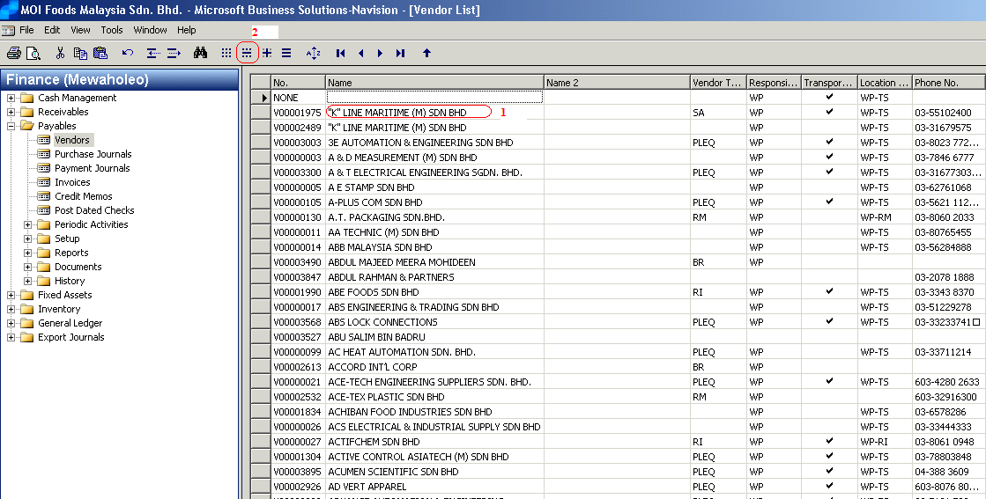

2.2 Search Vendor’s Name

Place cursor on column ‘Name’

Press button to set filter

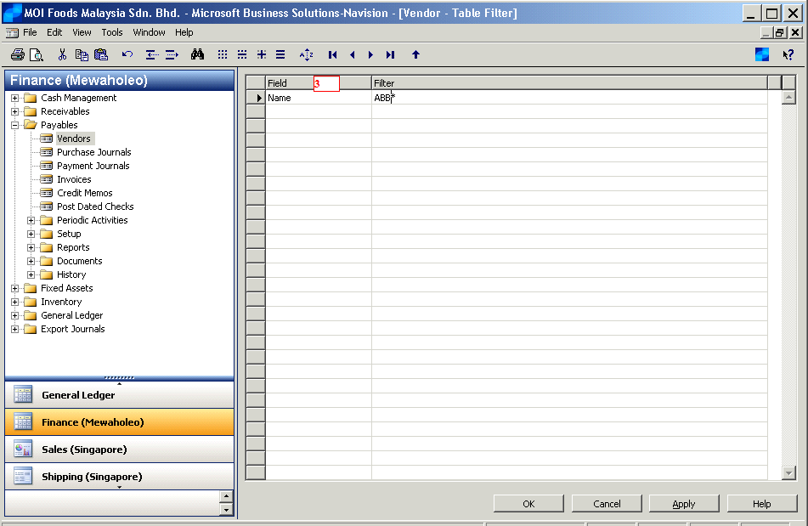

2.2.3 Key in the Vendor’s Name and press OK.

3.0 Existing Vendor

3.1 Check Currency
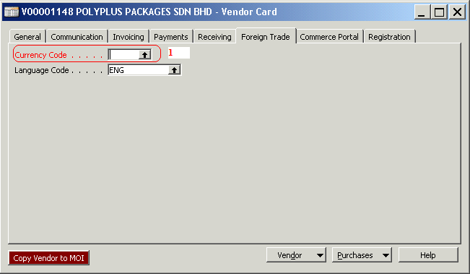

3.1.1 Foreign Trade
Open Tab ‘Foreign Trade’ to check current currency is same as you want; otherwise you may need to create another new vendor code for this vendor.

Check Summary
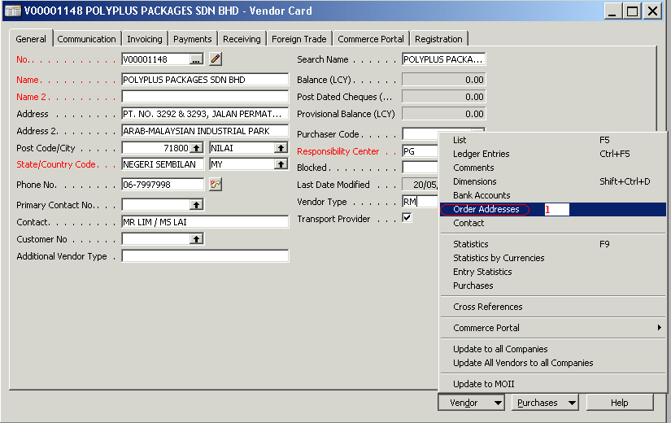

If all information are match but address is not match, ‘Order Addresses’ need to be fill in instead of create new vendor.

Press button ‘Vendor’ > ‘Order Addresses’ to key in another order address for this vendor.
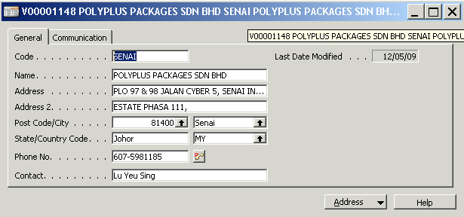

4.0New Vendor

Create new vendor by press ‘F3’ key.

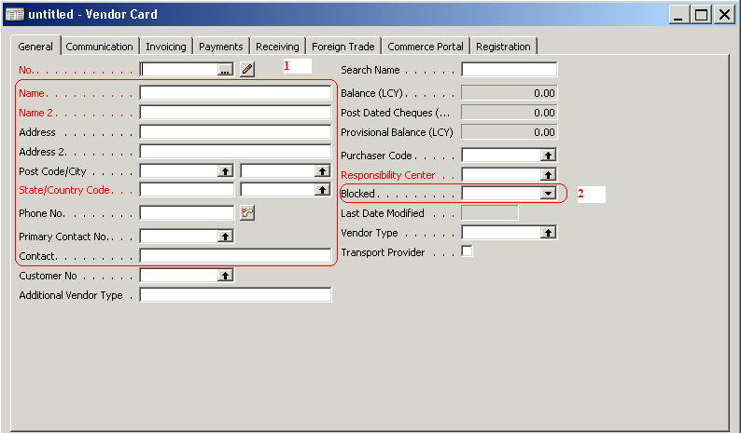

4.1 Tab General

4.1.1 Key in general information e.g. Name, Name 2, Address, Address 2, Post Code/City, State/Country Code, Phone No and etc.

Set ‘Responsibility Center’ to ‘PG’

Set ‘Blocked’ to ALL as this vendor will not be used for WP users

4.2 Tab Communication
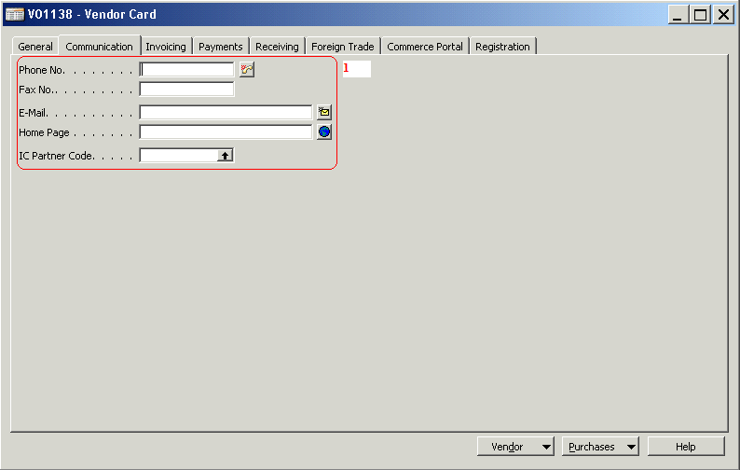

4.2.1 Key in communication’s information.

4.3 Tab Invoicing
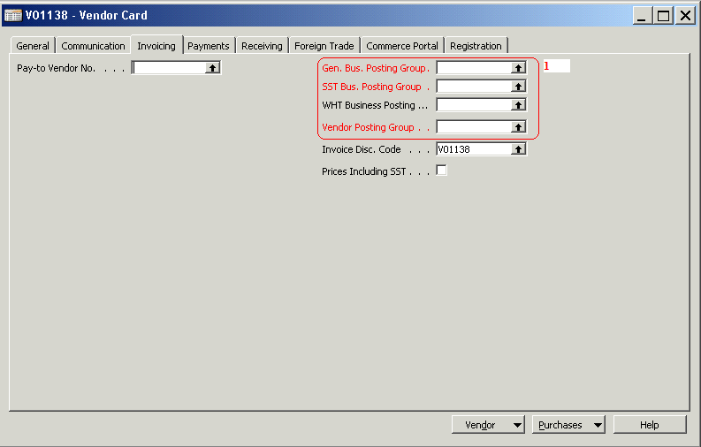

4.3.1 Key in posting group information.

4.4 Tab Payments
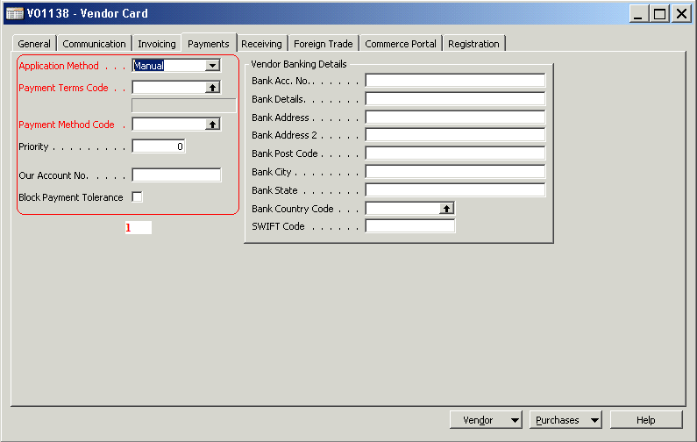

4.4.1 Key in payment information

4.5 Tab Receiving
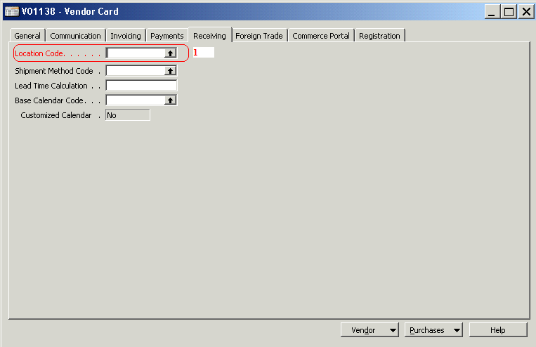

4.5.1 For Account Department, ‘Location Code’ should set as ‘PG-TS’

4.5.2 For CPD Department, ‘Location Code’ should set as ‘PG-PM’

4.6 Tab Foreign Trade
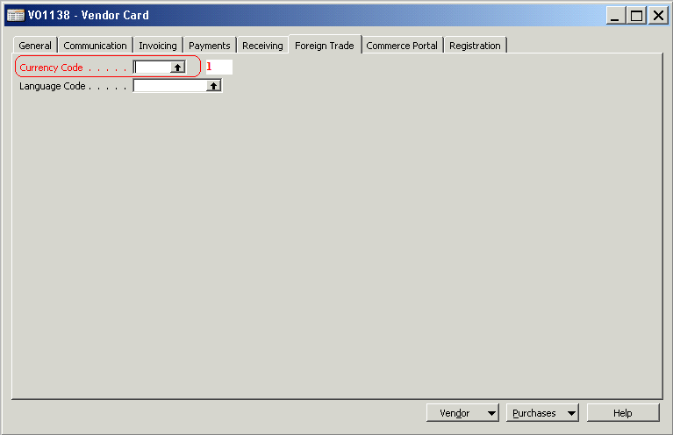

4.6.1 Select Currency Code.

4.7 Tab Commercial Portal
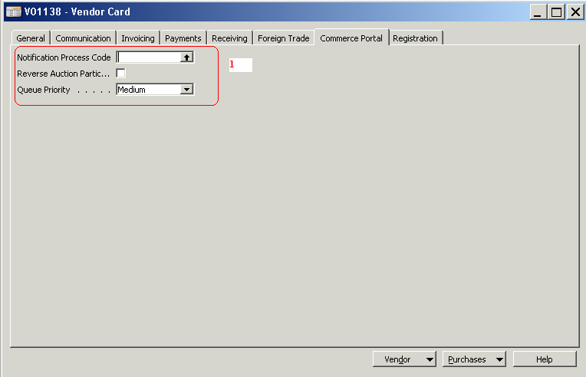

4.7.1 Select Commercial Portal information.

4.8 Tab Registration
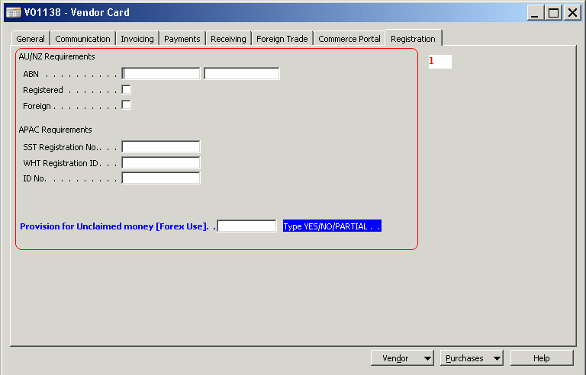

4.8.1 Key in Registration information.

5.0 Copy Vendor to MOI

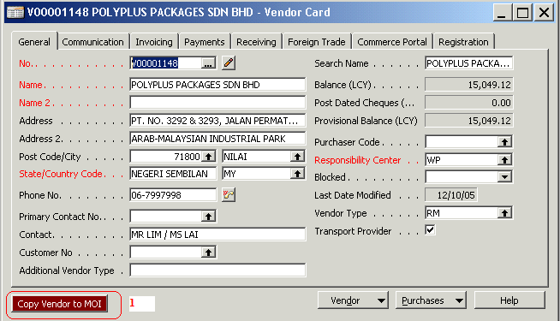

After all information is keyed, press button ‘Copy Vendor to MOI’ to copy the vendor’s data to Mewaholeo PG.

6.0 How to Check Vendor Is Copied

6.1 Log in to Navision – MEWAHOLEO Industries Sdn. Bhd.

6.1.1 File > Database > Open

6.1.2 File > Company > Open
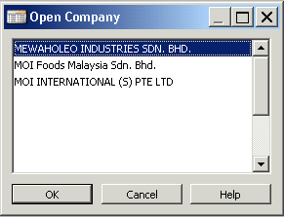

6.2 Select Finance (Mewaholeo) → Payables → Vendors

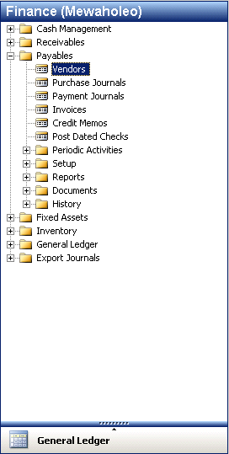

6.3 New Vendor Is Copied
